**Software Requirements**

**Specification**

**for**

**RDC – File Management System**

**Version 1.0 approved**

**Prepared by:**

**Buan, Michael John S.**

**Caranto, Edric Jon Cleon B.**

**Carlos, Christian Aleck S.**

**Asia Pacific College**

**November 21, 2016**

# Table of Contents

Table of Contents ii

Revision History ii

1. Introduction 1

1.1 Purpose 1

1.2 Document Conventions 1

1.3 Intended Audience and Reading Suggestions 1

1.4 Product Scope 1

1.5 References 1

2. Overall Description 2

2.1 Product Perspective 2

2.2 Product Functions 2

2.3 User Classes and Characteristics 2

2.4 Operating Environment 2

2.5 Design and Implementation Constraints 2

2.6 User Documentation 2

2.7 Assumptions and Dependencies 3

3. External Interface Requirements 3

3.1 User Interfaces 3

3.2 Hardware Interfaces 3

3.3 Software Interfaces 3

3.4 Communications Interfaces 3

4. System Features 4

4.1 System Feature 1 4

4.2 System Feature 2 (and so on) 4

5. Other Nonfunctional Requirements 4

5.1 Performance Requirements 4

5.2 Safety Requirements 5

5.3 Security Requirements 5

5.4 Software Quality Attributes 5

5.5 Business Rules 5

6. Other Requirements 5

Appendix A: Glossary 5

Appendix B: Analysis Models 5

Appendix C: To Be Determined List 6

# Revision History

|  |  |  |  |
| --- | --- | --- | --- |
| **Name** | **Date** | **Reason for Changes** | **Version** |
| Draft | 11/03/16 | Initial version of the SRS document | 1.0 |
| Revisions 1 | 11/21/2016 | Updated contents of the SRS document | 1.2 |

# Introduction

## Purpose

This Software Requirements Specification document describes the software functional and nonfunctional requirements for release 1.0 of the Document Management System for the Research Development Center of the Philippine Army. This document will be used by the project developers that will implement and check if the project is functioning properly.

## Document Conventions

This Document is arranged on Microsoft Word 2016 with “Arial” as font style and a font size of 11. Each part of the document title is set as heading 1 styles and its subtitle is set as heading 2 styles.

**Acronym and Abbreviations:**

1. DMS: Document Management System
2. RDC: Research Development Center

## Intended Audience and Reading Suggestions

This document is for the project developers, project advisers, project client, future users of the proposed system, and project defense panel. This SRS document contains the intended purpose of the system and what it will do and how it will perform.

## Product Scope

The file management system will allow faster document processing and reduce the paper usage of the office. A more detailed project description is available in the RDC – File Management System Project Vision and Scope Document.

## References

* RDC – Document Management System Project Vision and Scope Document
* RDC – Document Management System Statement of Work Document

# Overall Description

## Product Perspective

The RDC document management system is a system that replaces the current manual and paper based processing of item testing in RDC. The system enables employees of RDC to submit and acknowledge documents that is being processed by different departments without the use of papers. Furthermore, it enables employees of RDC to archive all documents being done.

<Diagram-context>

## Product Functions

The following are functions of the File management system:

* Employee
  + Admin
    - Can add/delete users accounts
    - Can add directive
    - Can archive final document folder
  + Tester
    - Can edit test worksheet
    - Can create/edit report document
  + Quality Assurance Division (QAD)
    - Can create/edit directive documents
  + Director/Officers
    - Can access documents
    - Can acknowledge and approve documents

<Diagram. top lvl DFD Ikaw bahala HIihi>

## User Classes and Characteristics

Stated below are the anticipated users of the proposed document management system.

* System Administrator

The admin has the highest among all users of the system having the right to register a user and assigns appropriate permissions to it. The admin must be able to archive documents done by other users.

* Tester

The testers are employees under the QAD and shall use the system while conducting a test by editing test worksheet document and creating report document. As soon as the testers are done, they can submit the documents and wait for approval.

* QAD

QAD are the employee who are creating directive documents such as implementation plan, item specification, and test worksheet. Also, they assign task/directive to the testers.

* Director & Officers

Director and Officer are users with higher privilege than QAD and Tester having the right to access documents at the same time acknowledge or approve documents submitted by the QAD and testers. The merely role of the director and officer in the system is to check the documents being submitted is approve or not. If not, it notifies the user who submits the document.

## Operating Environment

OE-1: The system shall operate in current versions of web browsers. Any web browsers (Mozilla Firefox, Google Chrome, or Microsoft Edge)

OE-2: The system shall operate with IBM Bluemix web hosting and may operate in a windows operating system.

## Design and Implementation Constraints

CO-1: All scripts must be written in PHP

CO-2: The system shall adapt the standards of web security

## User Documentation

The project team will provide user manuals for frontend and backend users. These manuals will include instructions on how to use the functionalities of the system and will be created for the employees of the RDC. Because of this, it is assumed that the readers of this manuals do not have absolute knowledge about the system.

## Assumptions and Dependencies

AS-1: the system will only operate during the RDC’s working hours.

AS-2: Admin can assign permissions to new user accounts

AS-3: All users can view the list of activities or task in a calendar

AS-4: General users can add documents on the system.

DE-1: The admin must register Employee

DE-2: The terminals must be connected to the internet

DE-3: Web browser is needed to access the system.

# External Interface Requirements

## User Interfaces

<Screenshot sa frontend and backend na ichura sa pagbukas>

## Hardware Interfaces

For client side:

**Hardware**: Minimum System Requirements

**Processor**: at least 1.6 GHz processor or above

**Disk Space**: 256GB or above

**Memory**: 2GB RAM or above

**Screen resolution**: at least 800 x 600 colors or above

## Software Interfaces

The needed software interfaces to use the RDC-File Management System are the following:

* Any version of Windows operating system environment
* The use of Web browsers, e.g. Chrome, Mozilla Firefox, Microsoft Edge, or Internet Explorer to view its contents
* All the User Interfaces; both the layout and functionality are done with the use of Yii2 advanced framework. It uses HTML, CSS, Bootstrap, JQuery, and PHP
* The database is included

## Communications Interfaces

* stable Internet connection
* Client side will be using HTTPS communication protocol
* A web browser

# System Features

## Import/Export an Excel File

**4.1.1 Description and Priority**

* Allows the user, with proper privileges, to import or export an excel file to the system.
* High priority since the office use excel files for their worksheets.

**4.1.2 Stimulus/Response Sequences**

|  |  |
| --- | --- |
| Stimulus | Response |
| Tester saves an excel file | System saves the excel file |
| User exports the excel file | System exports the excel file |

**4.1.3 Functional Requirements**

REQ-1: The user must log in to the system.

REQ-2: The user must have permissions to import/export an excel file

## Add an event to the calendar

**4.2.1 Description and Priority**

* Allows the user, with proper privileges, to add an event to the virtual calendar
* High priority since the office relies on their calendar for daily tasks.

**4.2.2 Stimulus/Response Sequences**

|  |  |
| --- | --- |
| Stimulus | Response |
| User adds an event | System adds event to the calendar |
| User views the calendar | System outputs the calendar |

**4.2.3 Functional Requirements**

REQ-1: The user must log in to the system

REQ-2: There should be directive details

REQ-3: The user must have permissions to add an event regarding testing

## Add, view, update, and delete a document

**4.3.1 Description and Priority**

* Allows the user, with proper privileges, to have access to CRUD functionalities
* High priority since the office produce different types of documents when testing an item.

**4.3.2 Stimulus/Response Sequences**

|  |  |
| --- | --- |
| Stimulus | Response |
| Add a document | System saves document to database |
| View a document | System outputs view of a document |
| Update a document | System updates a document in the database |
| Delete a document | System deletes the document from the database |

**4.3.3 Functional Requirements**

REQ-1: The user must log in to the system

REQ-2: A user that is assigned to specific permissions can only use functionalities that are appropriate to its position

# Other Nonfunctional Requirements

## Performance Requirements

Performance requirements defines response times towards the functionality of the system. Regardless of the errors that happened wh en developing this system. The result of this system will be based on the hardware and software components of the computer that will be used.

## Safety Requirements

There are user levels in the system that have different access in the functionalities of the system. It also has a log in page wherein the user logins their username and password. By logging in each account will be given accessible functions of the system per their user level.

## Security Requirements

The administrative division, quality assurance division (QAD), and other employees will be able to log in to the system. Each user will have access to functionalities of the system but with certain privileges only. QAD will have higher access than the staff due to their ranks. The admin will have all the functionalities of the system; He can also ensure the security of the system by the log in page that needs his permission to add a user

## Software Quality Attributes

1. Maintainability: Keeping and repairing would be fast and easy which can be restored to operational status after a failure has occurred.
2. Reliability: The system will be expected to produce stable and consistent results.
3. Security: Features of this system will depend on the rank of the user and will be also requiring the user to log in before having an access to the system.
4. Efficiency: The system lessens the time and reduce the use of paper to simply finish a certain report through the system.
5. Usability: The system is expected to have user-friendly features which helps the user to use the system with ease.

## Business Rules

RDC Document Management System will function under different users those are the Admin, QAD, Director, QAD Tester. The system is created that all functionalities will be divided between the Admin, QAD, Director and QAD tester. The part of the Admin can take control of everything that happens in the system. While the QAD can add, and create a test worksheet. Some features which is conducting a test and filling up a worksheet will be assigned to the QAD tester. While the Director is given the authority to approve or disapprove the documents from the QAD which is related to the directive that was given to the RDC.

# Appendix A: Glossary

**Directive** an official or authoritative instruction

**Implementation** **plan** is a management tool designed to illustrate, in detail, the critical steps in developing and starting a project.

**Director** a member of the board of people that manages or oversees the affairs of a business.

**Quality** **Assurance** **Division** is to improve the management performance level, accountability, and data reporting of local public housing agencies participating in the Department's voucher rental assistance and homeownership programs and to maximize the cost and management effectiveness and efficiency of the programs.

**Tester** a person who tests something, especially a new product.

**Administrator** a person responsible for running a business, organization, etc.

**Worksheet** a paper for recording work done or in progress

**Test** **documents** a piece of written, printed, or electronic matter that provides information or evidence or that serves as an official record.

# Appendix B: Analysis Models

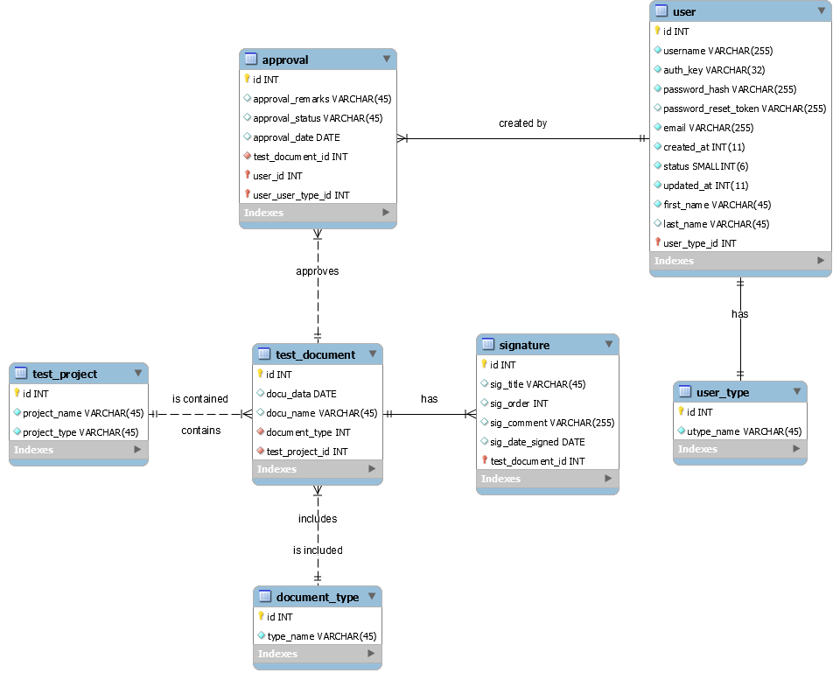

# Appendix C: To Be Determined List

<Collect a numbered list of the TBD (to be determined) references that remain in the SRS so they can be tracked to closure.>